DBMS ASSIGNMENT-4

Q1. Count the total number of Students.

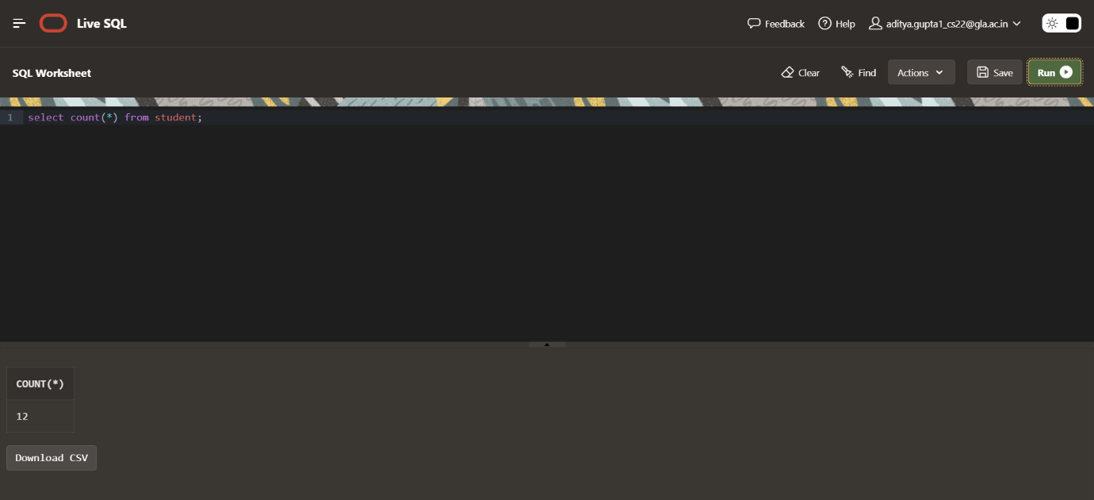

Q2. Calculate the average GPA of all Student.

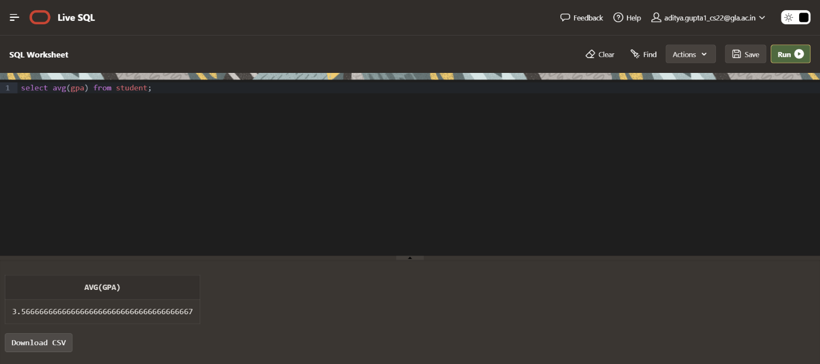

Q3. Determine the minimum and maximum GPA. Rename the titles as ‘max_GPA’ and ‘min_GPA’ respectively.

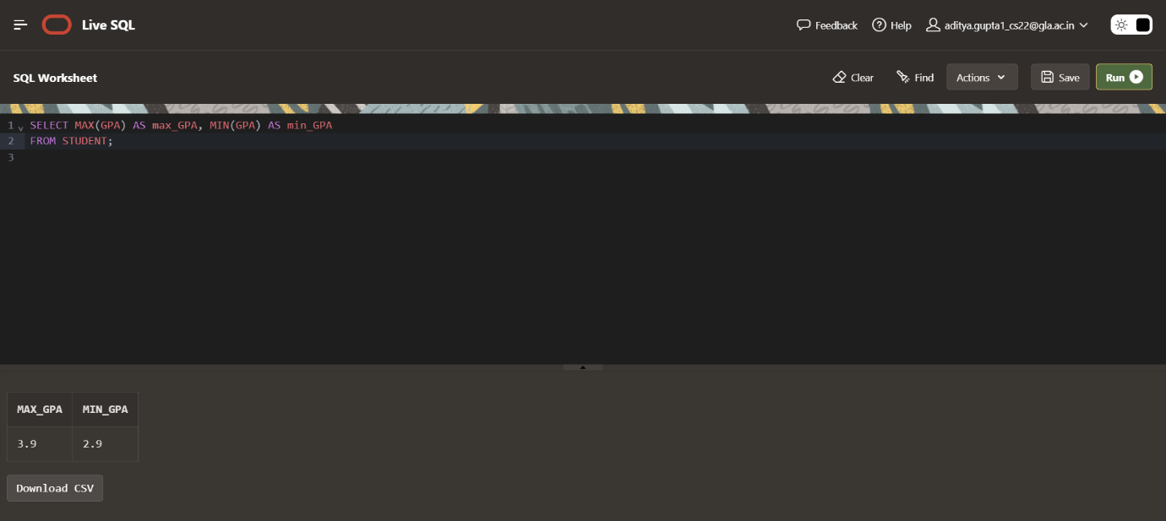

Q4. Count the number of students having GPA greater than or equal to 3.7.

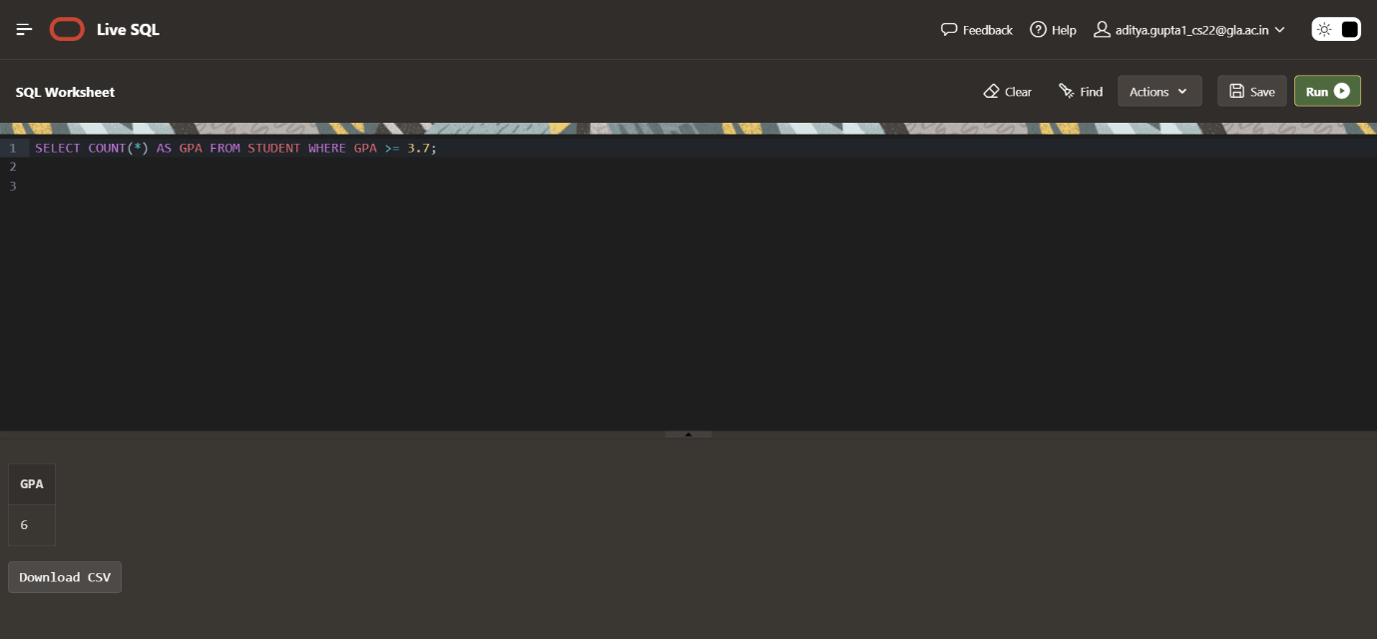

Q5. Find Maximum, Average, Minimum, total GPA of all student.

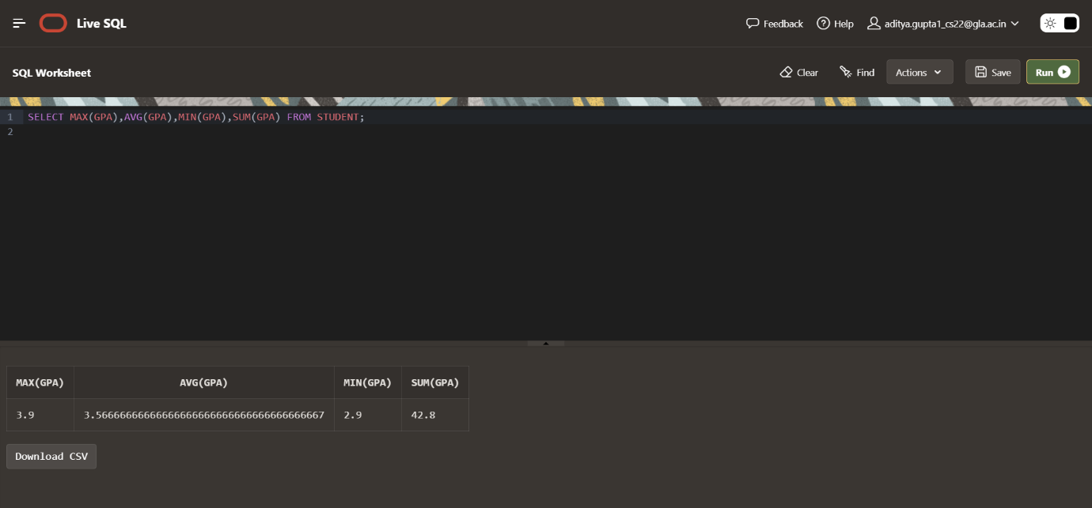

Q6. Find total number of colleges in our Application Database.

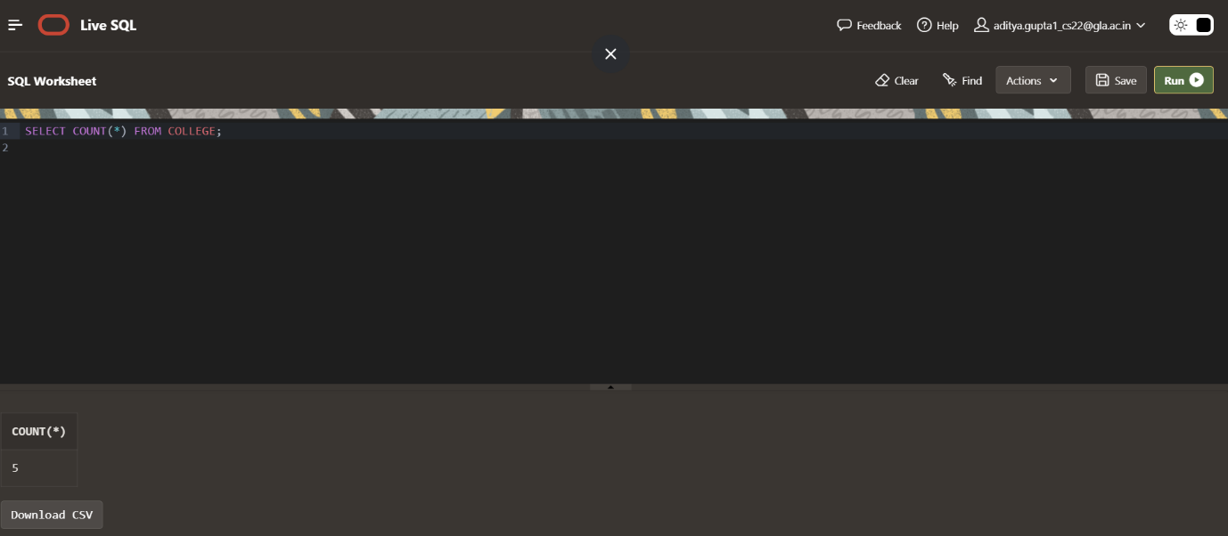

Q7. Find how many different majors student had applied in.

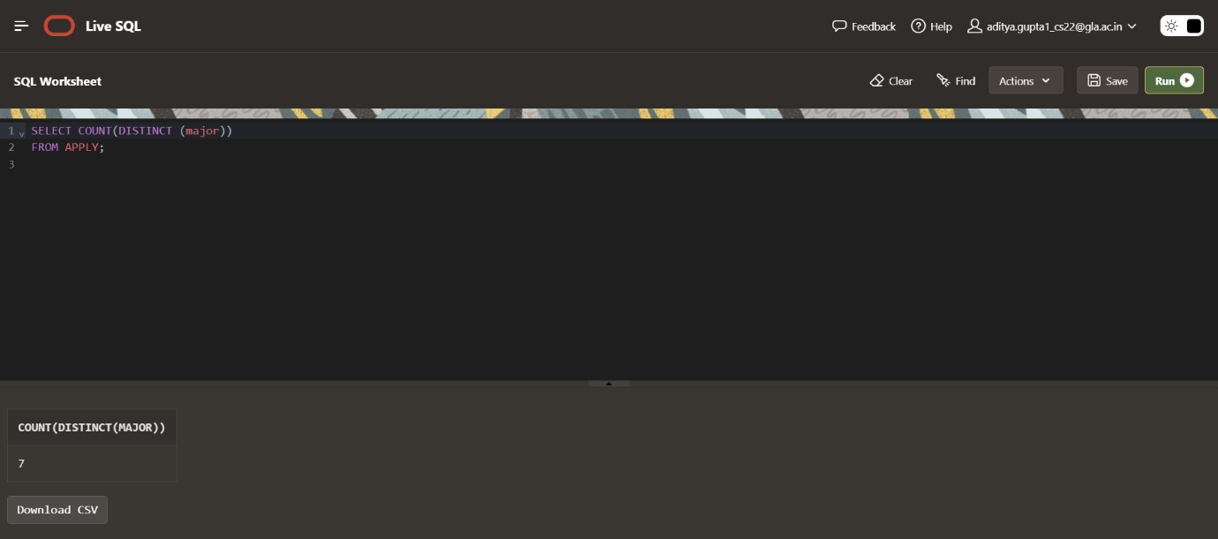

Q8. Find total no. of Applications in our Application System’s Database.

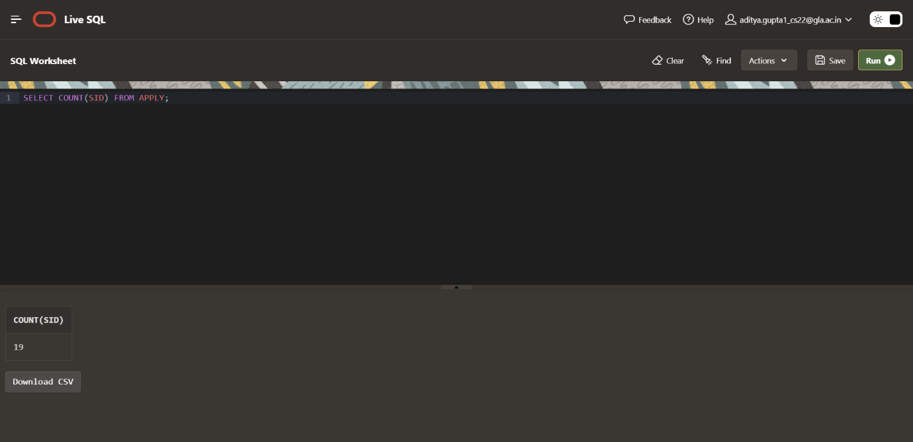

Q9. Find average of all distinct GPA.

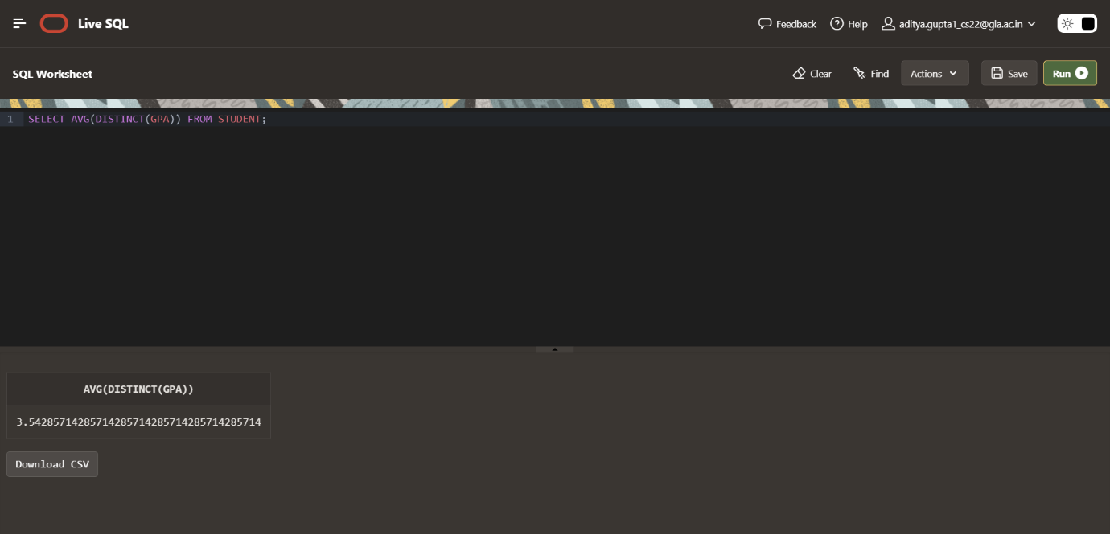

Q10. Display the total number of application accepted.

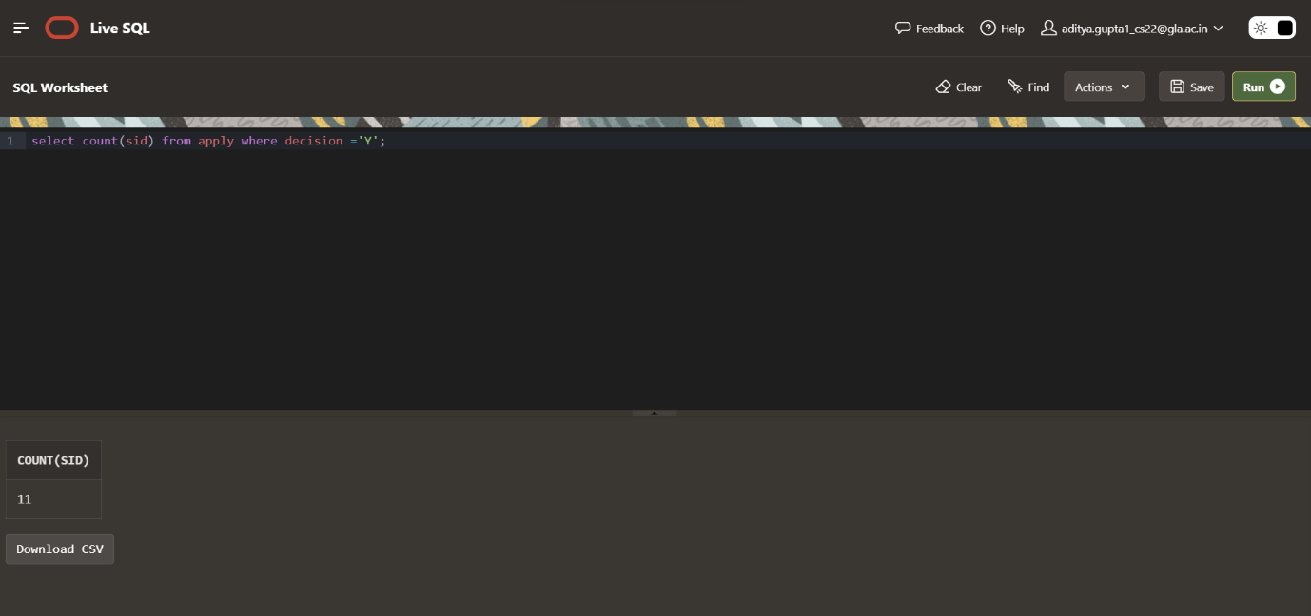

Q11. Find number of students having GPA>3.4 and coming from high school having size>1000.

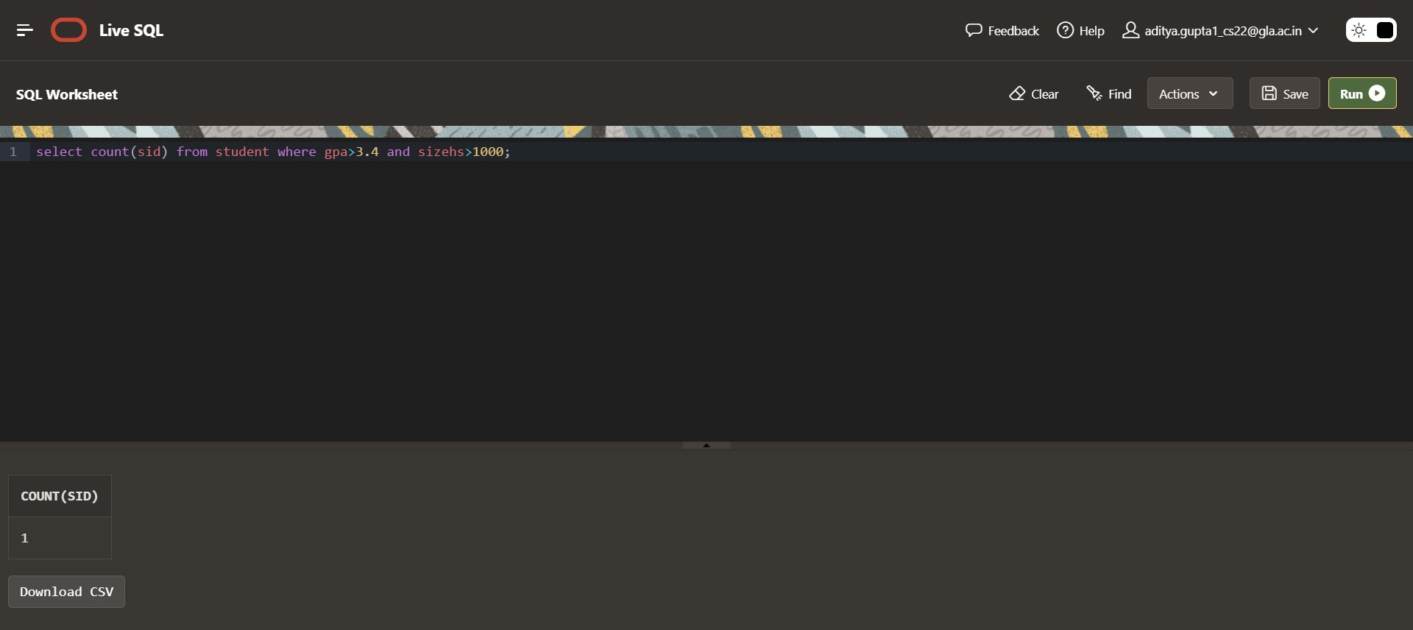

Q12. Find how many student applied to ‘marine biology’.

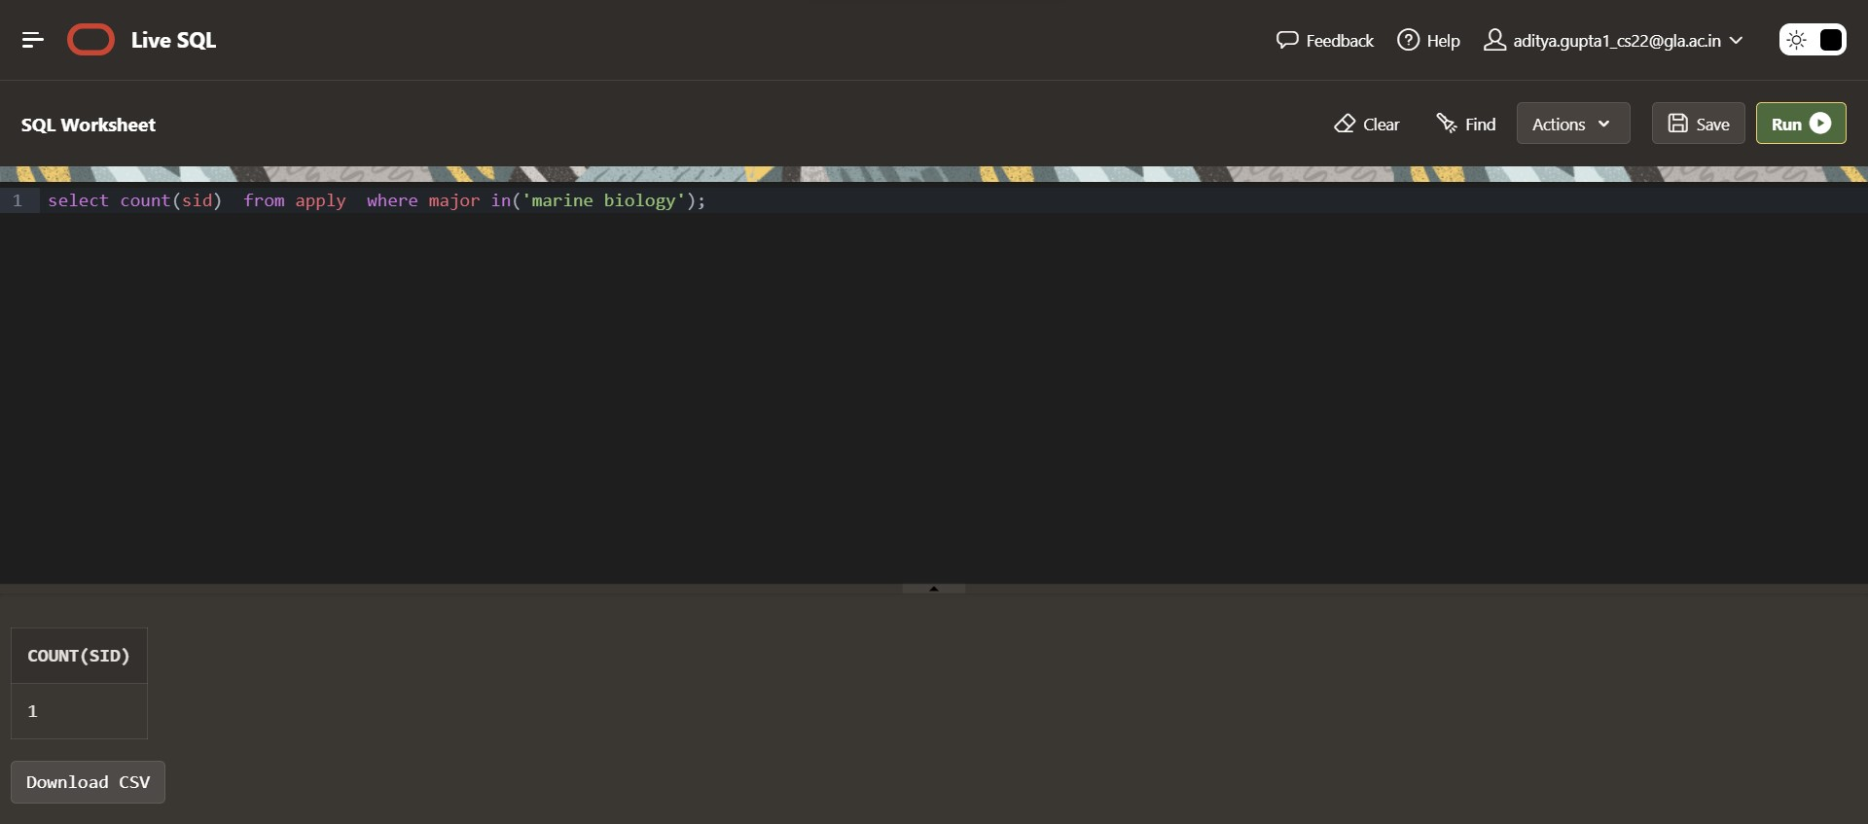

Q13. Find how many applications were rejected and accepted by the colleges.

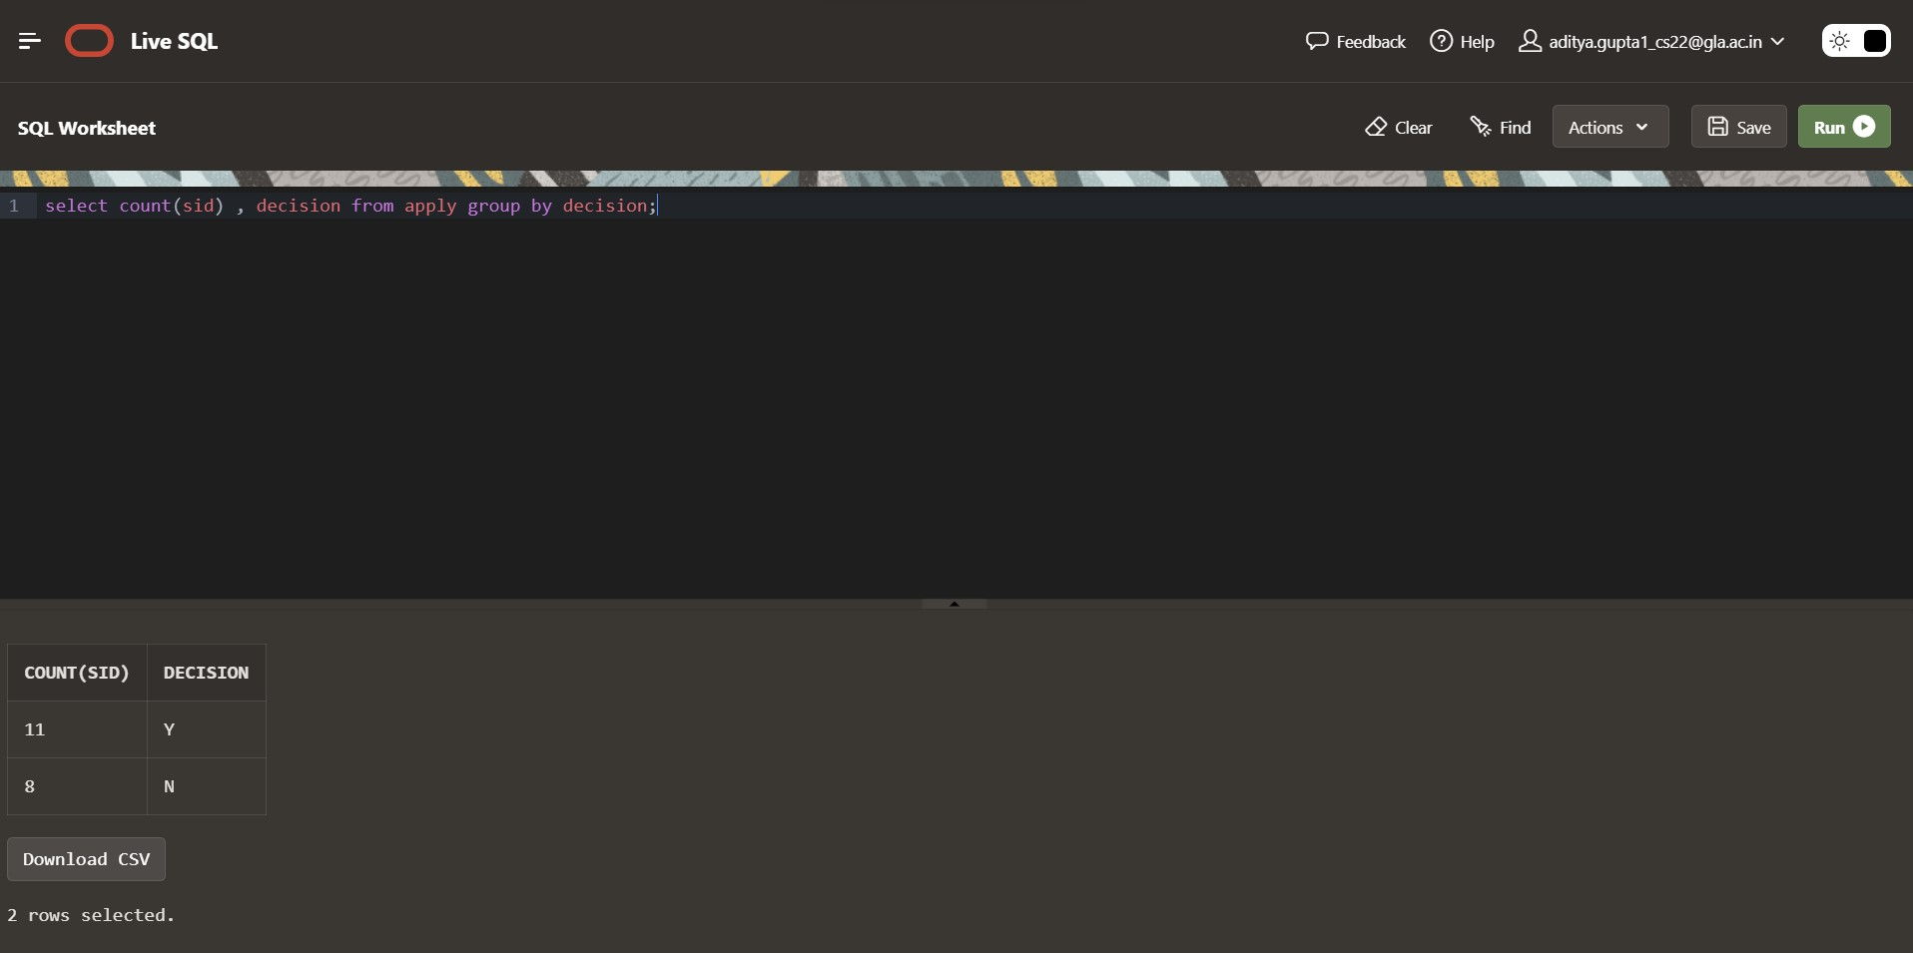

Q14. Find how many students applied to a particular major. (show count(sid) as No_of_applications).

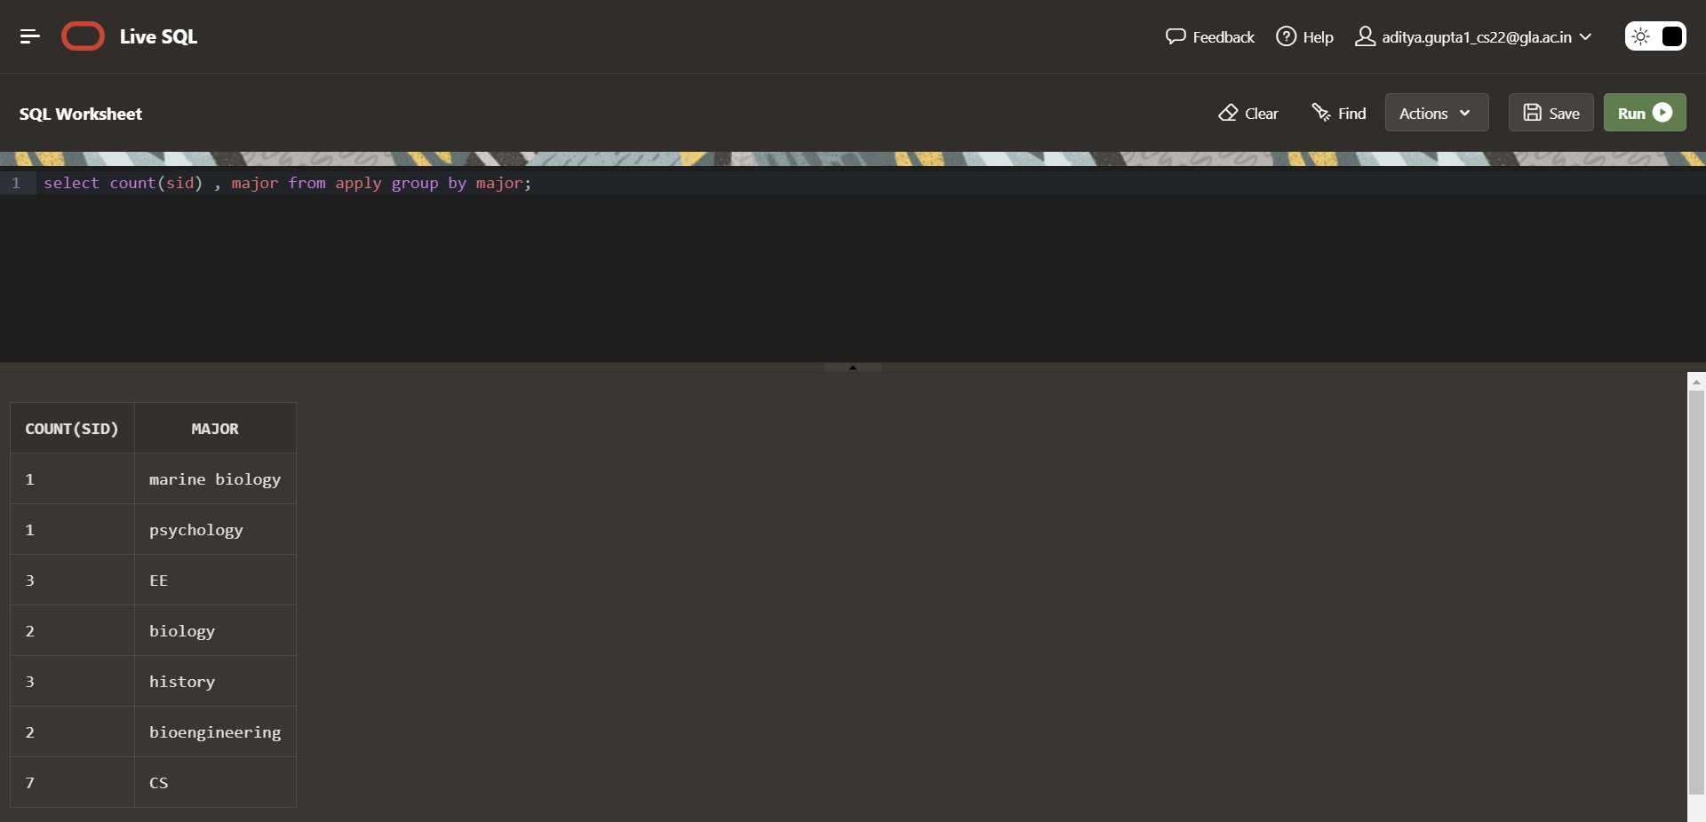

Q15. Find number of applications received by particular college.

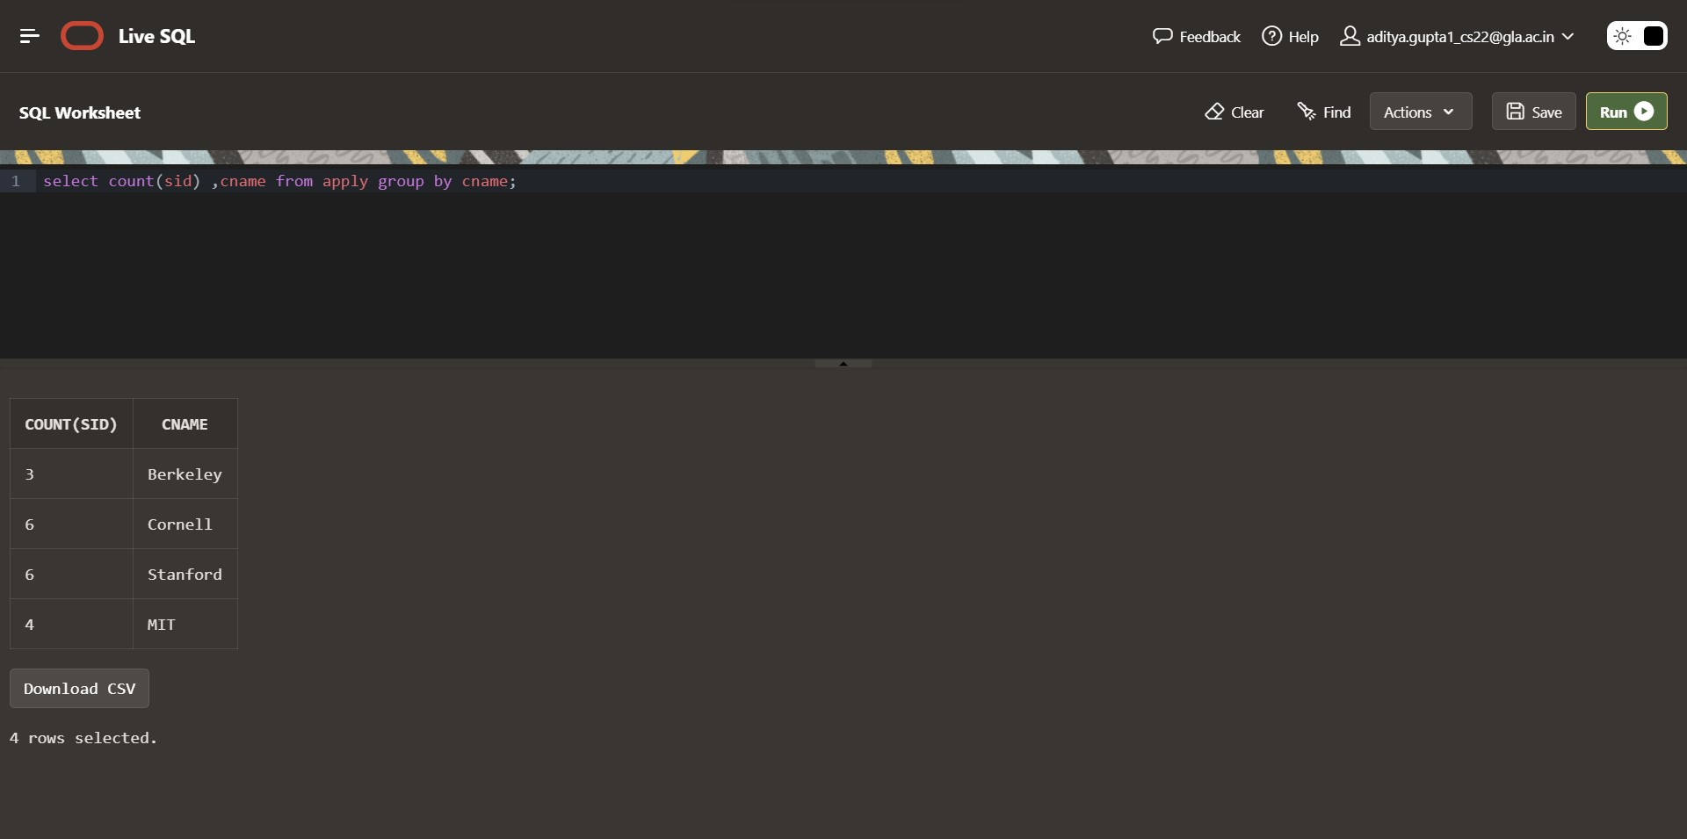

Q16. Find number of applications received in a particular major at a particular college.

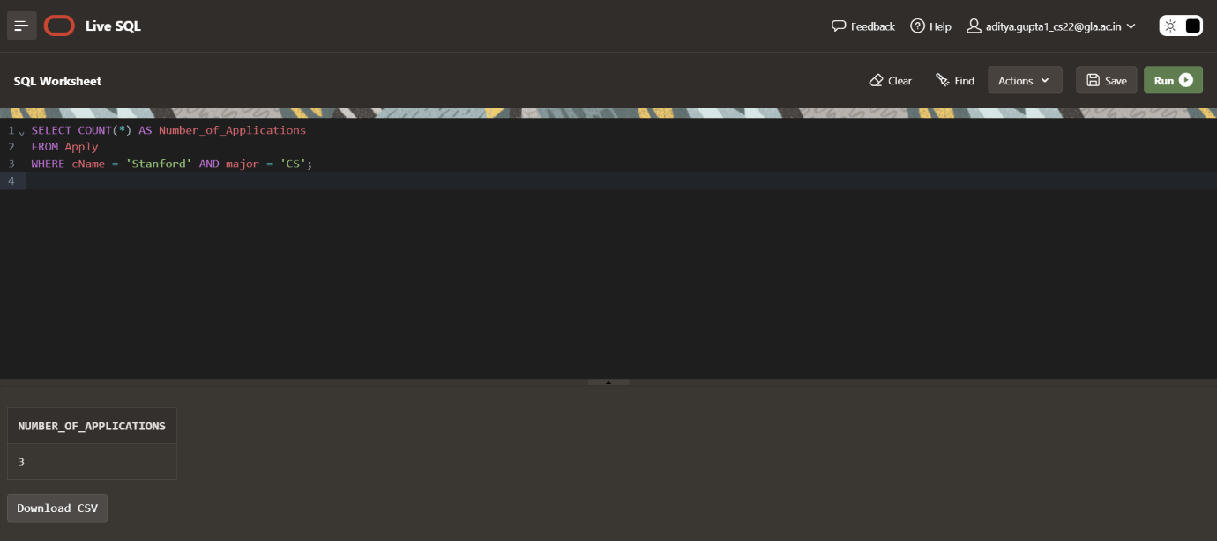

Q17. Give the college name and major, where number of applications received are greater than or equal to 2.

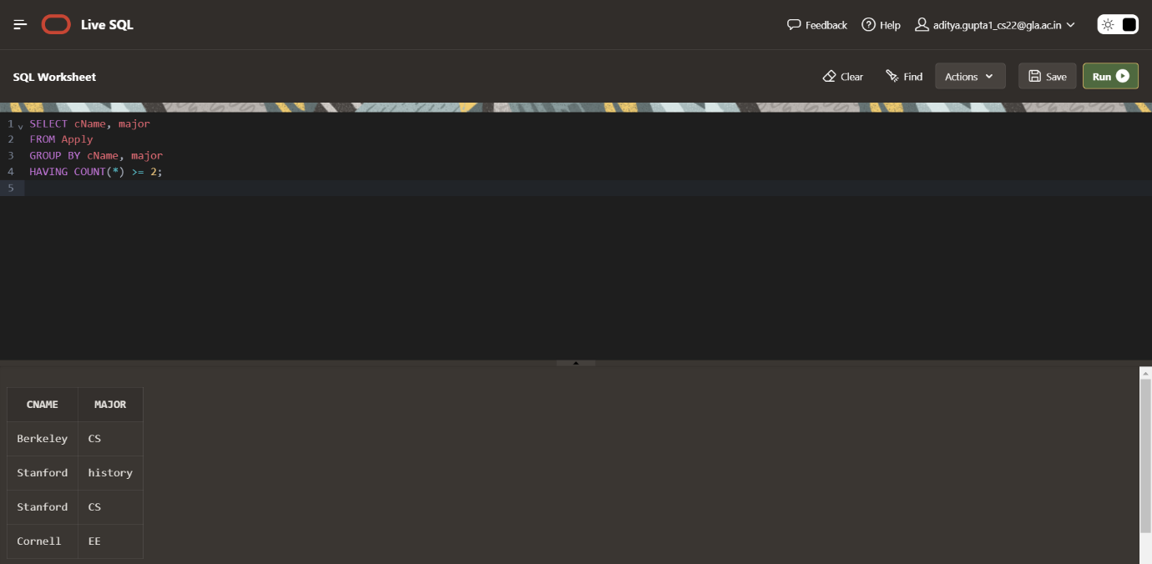

Q18. Give the name and no of applications of all those colleges which receives applications from 3 or more students.

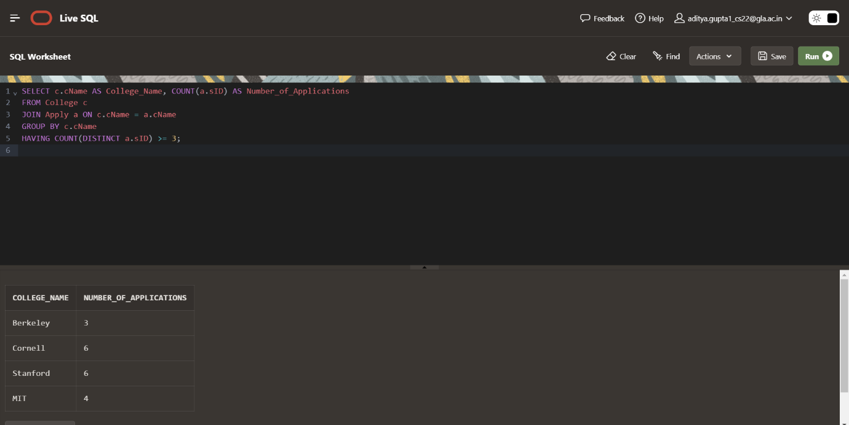

Q19. Give state and number of colleges of a state that has more than 1 college.

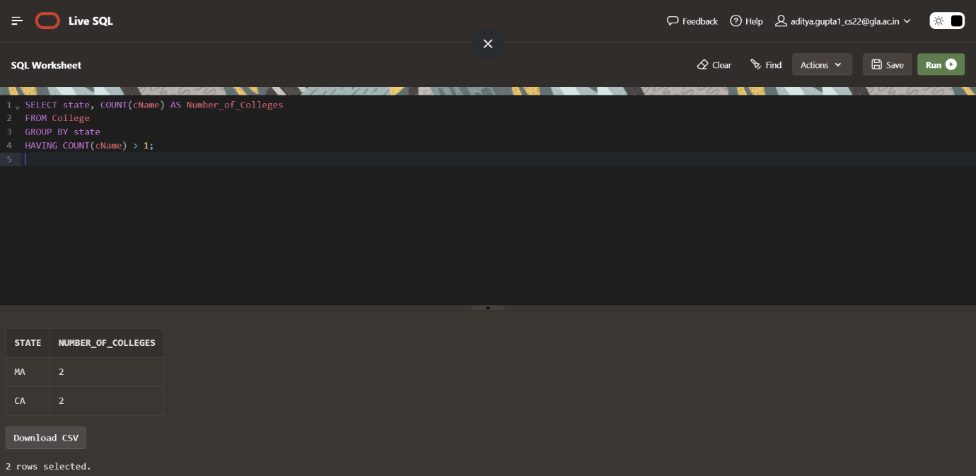

Q20. Find the name of students that are duplicate. Q20. Find the name of students that are duplicate.

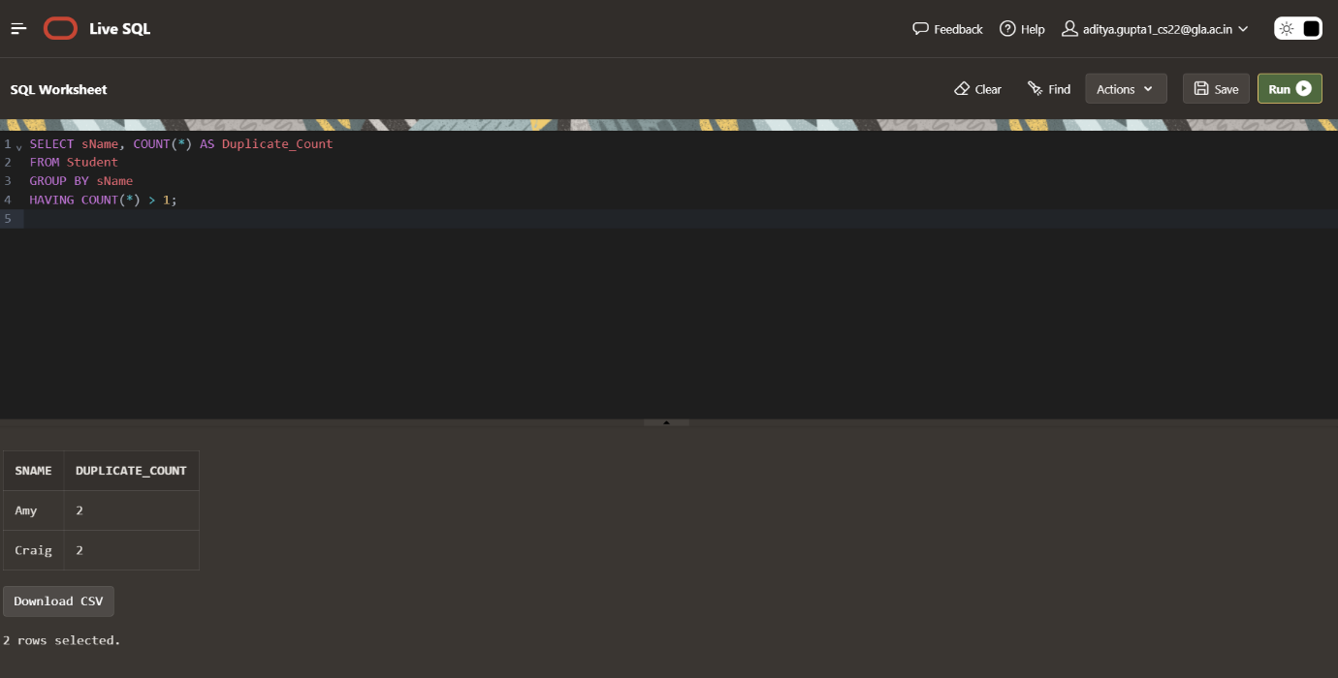

NAME 🡪 ADITYA GUPTA

SECTION 🡪 B

UNIV ROLLNO. 🡪 2215000094

CLASS ROLLNO. 🡪47